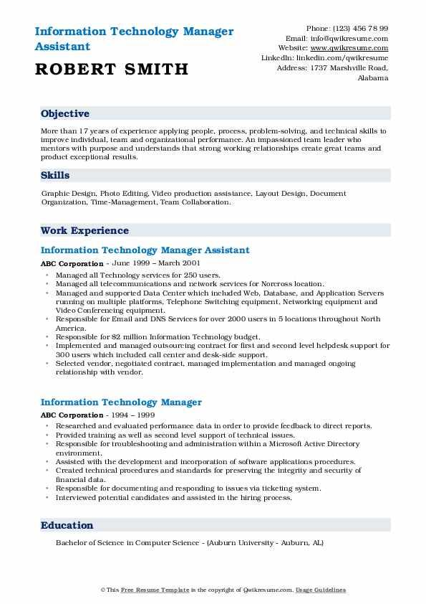
Information Technology Manager
Assistant
ROBERT SMITH
Phone: (123) 456 78 99
Email: info@qwikresume.com Website: www.qwikresume.com Linkedin: linkedin.com/qwikresume Address: 1737 Marshville Road,
Alabama
Objective
More than 17 years of experience applying people, process, problem-solving, and technical skills to improve individual, team and organizational performance. An impassioned team leader who mentors with purpose and understands that strong working relationships create great teams and product exceptional results,
Skills
Graphic Design, Photo Editing. Video production assistance. Layout Design, Document Organization, Time-Management, Team Collaboration.
Work Experience
Information Technology Manager Assistant
ABC Corporation - June 1999 - March 2001
⚫ Managed all Technology services for 250 users.
⚫ Managed all telecommunications and network services for Norcross location.
Managed and supported Data Center which included Web, Database, and Application Servers running on multiple platforms, Telephone Switching equipment, Networking equipment and Video Conferencing equipment.
⚫Responsible for Email and DNS Services for over 2000 users in 5 locations throughout North America.
• Responsible for $2 million Information Technology budget.
Implemented and managed outsourcing contract for first and second level helpdesk support for 300 users which included call center and desk-side support.
• Selected vendor, negotiated contract, managed implementation and managed ongoing relationship with vendor.
Information Technology Manager
ABC Corporation - 1994 - 1999
⚫ Researched and evaluated performance data in order to provide feedback to direct reports. • Provided training as well as second level support of technical issues.
• Responsible for troubleshooting and administration within a Microsoft Active Directory environment.
⚫ Assisted with the development and incorporation of software applications procedures.
• Created technical procedures and standards for preserving the integrity and security of financial data.
Responsible for documenting and responding to issues via ticketing system.
⚫ Interviewed potential candidates and assisted in the hiring process,
Education
Bachelor of Science in Computer Science - (Auburn University - Auburn, AL)
This Free Resume Template is the copyright of Qwikresume.com. Usage Guidelines

